**TASK 1:**

#include<iostream>

using namespace std;

int main()

{

int size;

cout << "Enter the size of the array :";

cin >> size;

int *p = new int[size];

cout << "Enter the elements of the array :"<<endl;

for (int i = 0; i < size; i++)

{

cin >> p[i];

}

int a = size / 2;

cout << "The elements after swapping are :"<<endl;

for (int i = 0; i < a; i++)

{

if (size % 2 == 0)

{

if (p[i] < p[i + a])

{

int temp = p[i + a];

p[i + a] = p[i];

p[i] = temp;

}

}

else

{

if (p[i] < p[i + a + 1])

{

int temp = p[i + a + 1];

p[i + a + 1] = p[i];

p[i] = temp;

}

}

}

for (int i = 0; i < size; i++)

{

cout << p[i]<<endl;

}

system("pause");

}

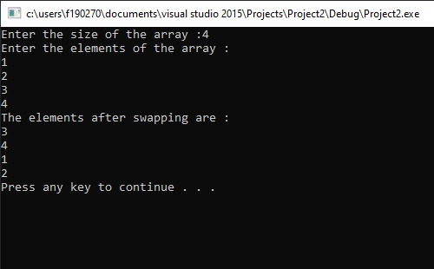

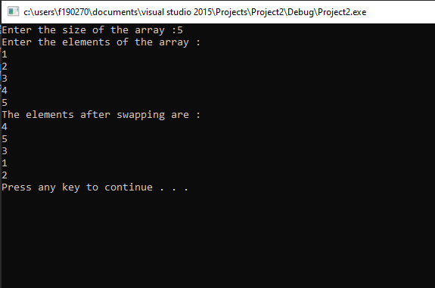

**TASK 2:**

#include<iostream>

using namespace std;

int main()

{

int size, count = 0;

cout << "Enter the size of the array :";

cin >> size;

int odd = 1, even = 0;

int* p = new int[size];

cout << "Enter the elements of the array :" << endl;

int oddmax, evenmax, evencount = 0, oddcount = 0;

if (size % 2 == 0)

{

evenmax = size / 2;

oddmax = size / 2;

}

else

{

evenmax = size / 2 + 1;

oddmax = size / 2;

}

for (int i = 0; i < size; i++)

{

int x;

again:

cin >> x;

if (x % 2 == 0)

{

if (evencount < evenmax)

{

p[even] = x;

even = even + 2;

evencount++;

}

else

{

cout << "Even spaces are full enter odd" << endl;

goto again;

}

}

else

{

if (oddcount < oddmax)

{

p[odd] = x;

odd = odd + 2;

oddcount++;

}

else

{

cout << "Odd spaces are full enter even" << endl;

goto again;

}

}

}

cout << endl;

for (int i = 0; i < size; i++)

{

cout << p[i] << " " << endl;

}

system("pause");

}

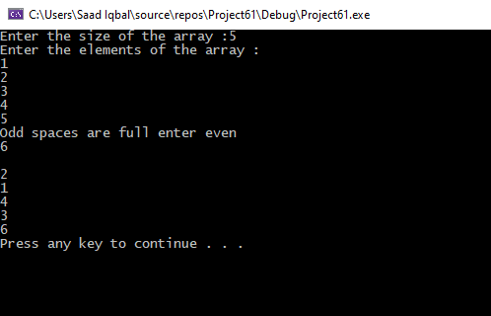

**TASK 3**

#include<iostream>

using namespace std;

int main()

{

int size;

cout << "Enter Size of Array :";

cin >> size;

int* ptr = new int[size];

int choice;

cout << "Enter elements of array :"<<endl;

for (int i = 0; i < size; i++)

{

cin >> *(ptr + i);

}

cout << endl;

int max = 0;

for (int i = 0; i < size; i++)

{

if (*(ptr + i) > max)

{

max = *(ptr + i);

}

}

cout << max;

int* arr = new int[max];

for (int i = 0; i < size; i++)

{

for (int j = 0; j < max; j++)

{

if (j == ptr[i])

{

arr[j] = ptr[i];

break;

}

}

}

cout << "The values in the indexes are :" << endl;

for (int i = 0; i < max; i++)

{

cout << "Value of Array[" << i << "] = " << *(arr + i) << endl;

}

}

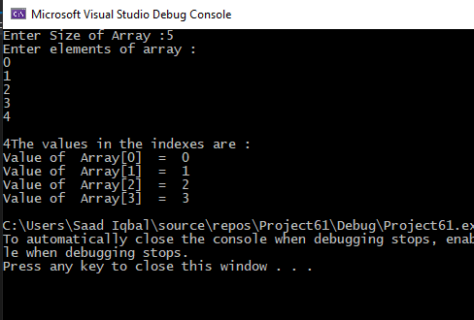

**TASK 4:**

#include<iostream>

#include<ctime>

#include<string>

using namespace std;

int main()

{

string name, disease_name;

char op;

int sl;

int p[5] = { 1,2,3,4,5 };

srand(time(0));

cout << "Enter name of the patient :";

cin >> name;

cin.ignore();

cout << "Enter disease of the patient :";

getline(cin,disease_name);

cout << "Do you want to choose the slot {Y/N}";

cin >> op;

if (op == 'Y')

{

cout << "slots 1,2,3,4,5 available please choose :";

cin >> sl;

for (int i = 0; i < 5; i++)

{

if (p[i] != sl)

{

cout << "Slot is not availabe :"<<endl;

cout << "Do you want to choose the slot again {Y/N}";

cin >> op;

cout << "you have been allotted " << rand() % 5 << endl;

break;

}

else

{

cout << "yOU HAVE ALLOTTED " << p[i];

}

}

}

system("pause");

}

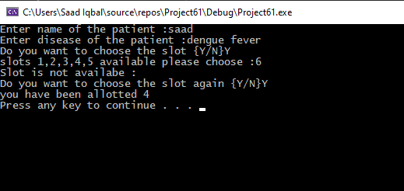

**Task 5:**

#include<iostream>

using namespace std;

int main()

{

int size;

cout << "Enter the size of the array :";

cin >> size;

int *p = new int[size];

cout << "Enter the elements of the array :" << endl;

for (int i = 0; i < size; i++)

{

cin >> p[i];

}

cout << "the divisor of enteries are: "<<endl;

for (int i = 0; i < size; i++)

{

for (int j = 1; j <= p[i]; j++)

{

if (p[i] % j == 0)

{

cout <<"\t"<< j;

}

}

cout << endl;

}

system("pause");

}

